**Date: 29/03/2024 Prepared By: Shrikanth C R**

**INTEGRATING TERRAFORM WITH JENKINS PIPELINE:**

**PREQUISITES:**

**1) Install Jenkins in One Ec2 Server: (Jenkins Master)**

yum update -y

yum install java-17 -y

yum install git -y

yum install mvn -y

yum install docker -y

systemctl start docker

systemctl enable docker

systemctl status docker

docker run -d -p 8080:8080 -p 50000:50000 jenkins/jenkins:lts

**2) For Jenkins Slave:**

yum update -y

yum install java-17 -y

yum install git -y

yum install mvn -y

**Run Below Commands to connect Jenkins-slave with Jenkins-Master:**

curl -sO http://54.152.5.61:8080/jnlpJars/agent.jar

java -jar agent.jar -url http://54.152.5.61:8080/ -secret

12fa91f4004e91707899d75b576ae1e722994b73ec7fe3ee89d60dff88e19996 -name "slave-1" -

workDir "/home/ec2-user/"

**Terraform Installation Commands:**

sudo yum install -y yum-utils shadow-utils

sudo yum-config-manager --add-repo https://rpm.releases.hashicorp.com/AmazonLinux/hashicorp.repo

sudo yum -y install terraform

sudo terraform –version

**Git Hub Link:** <https://github.com/Shrikanth-C-R/Terraform-Project.git>

**3) Plugins:**

**1) Terraform Plugin**

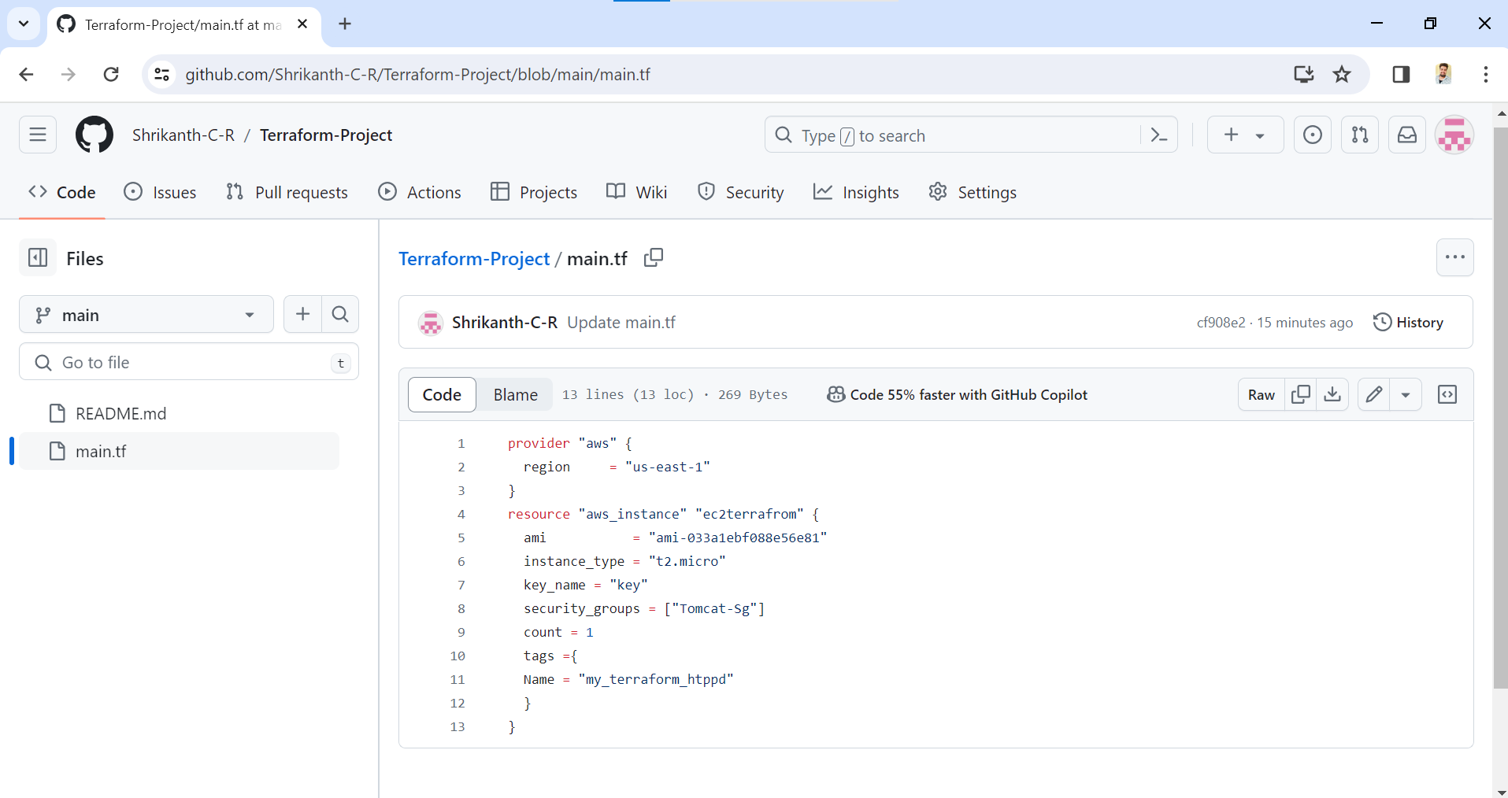

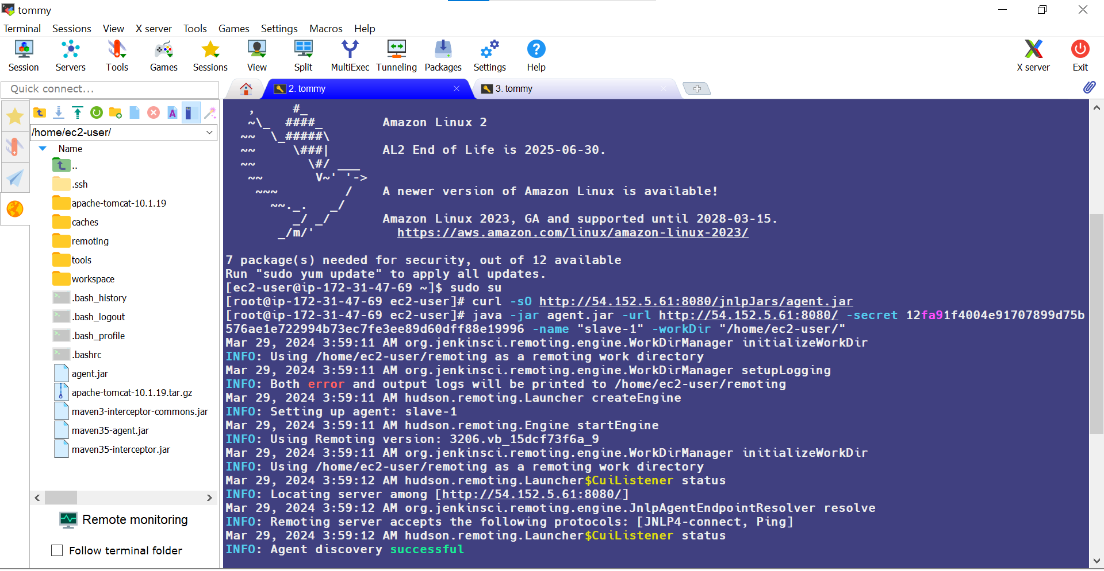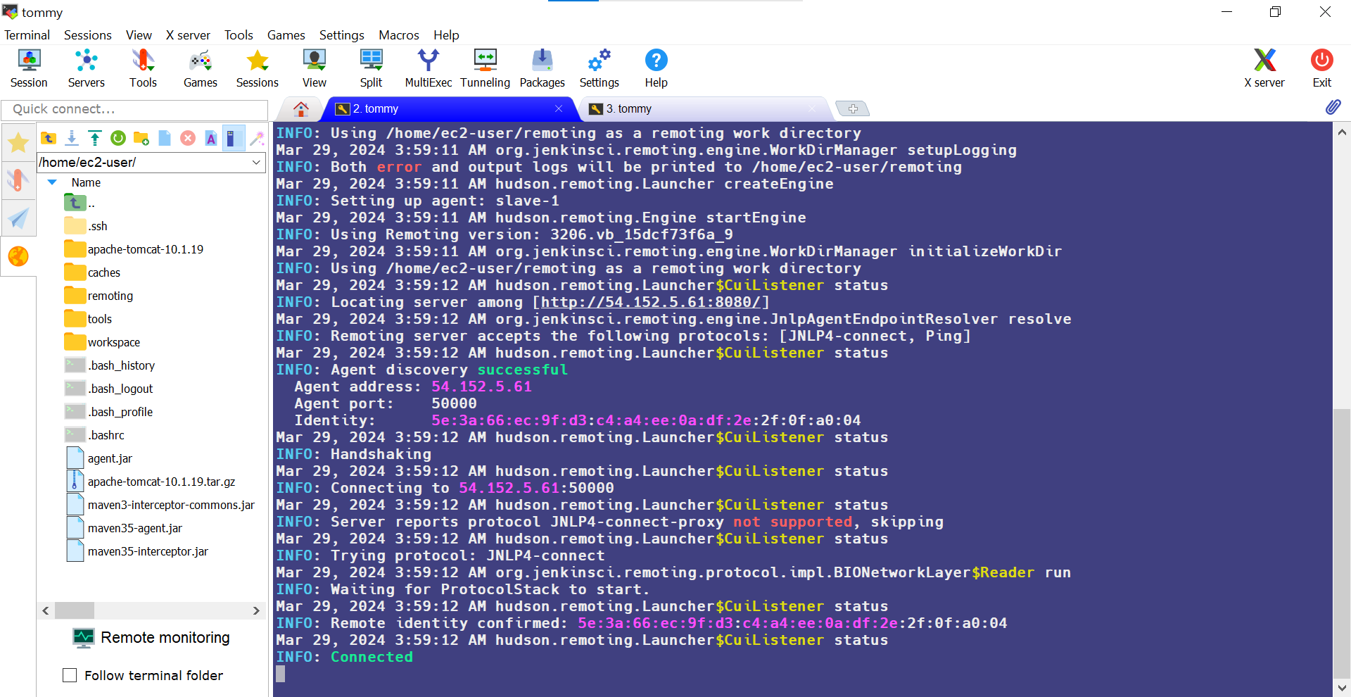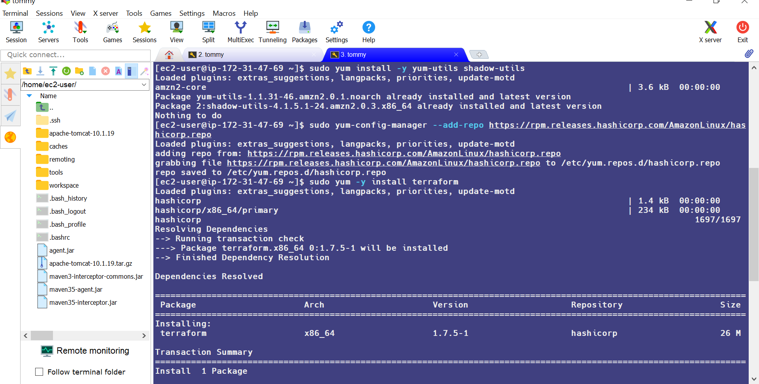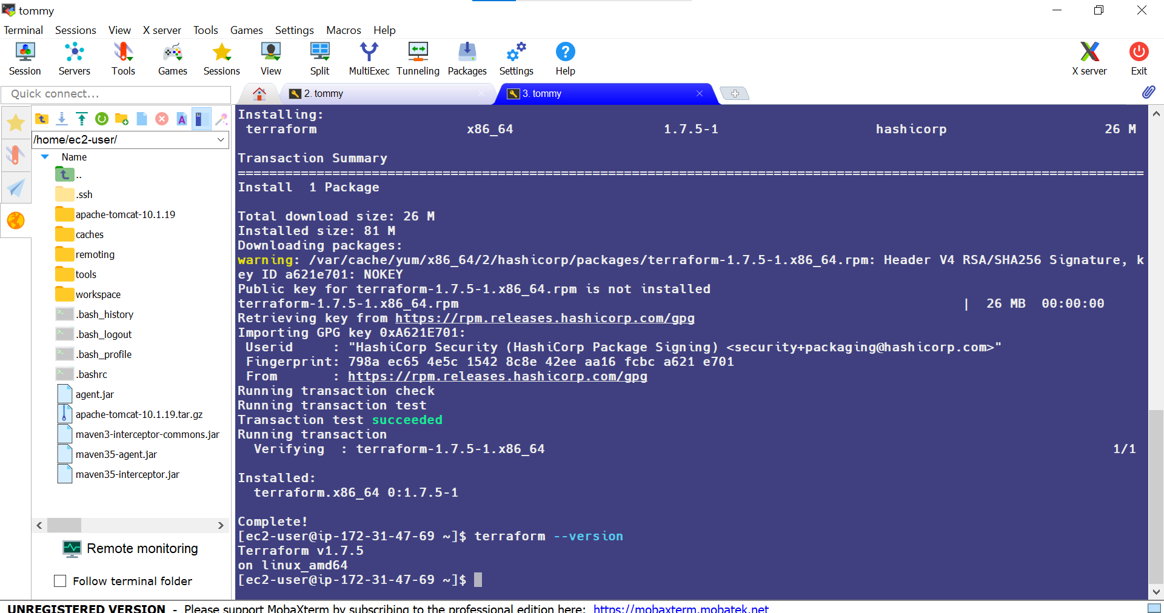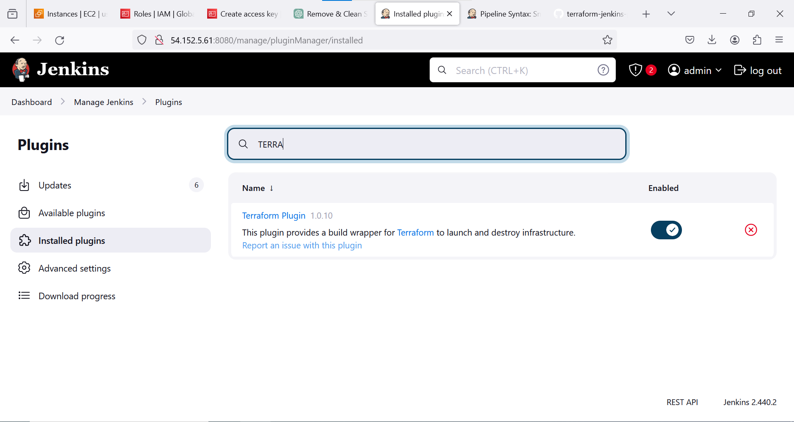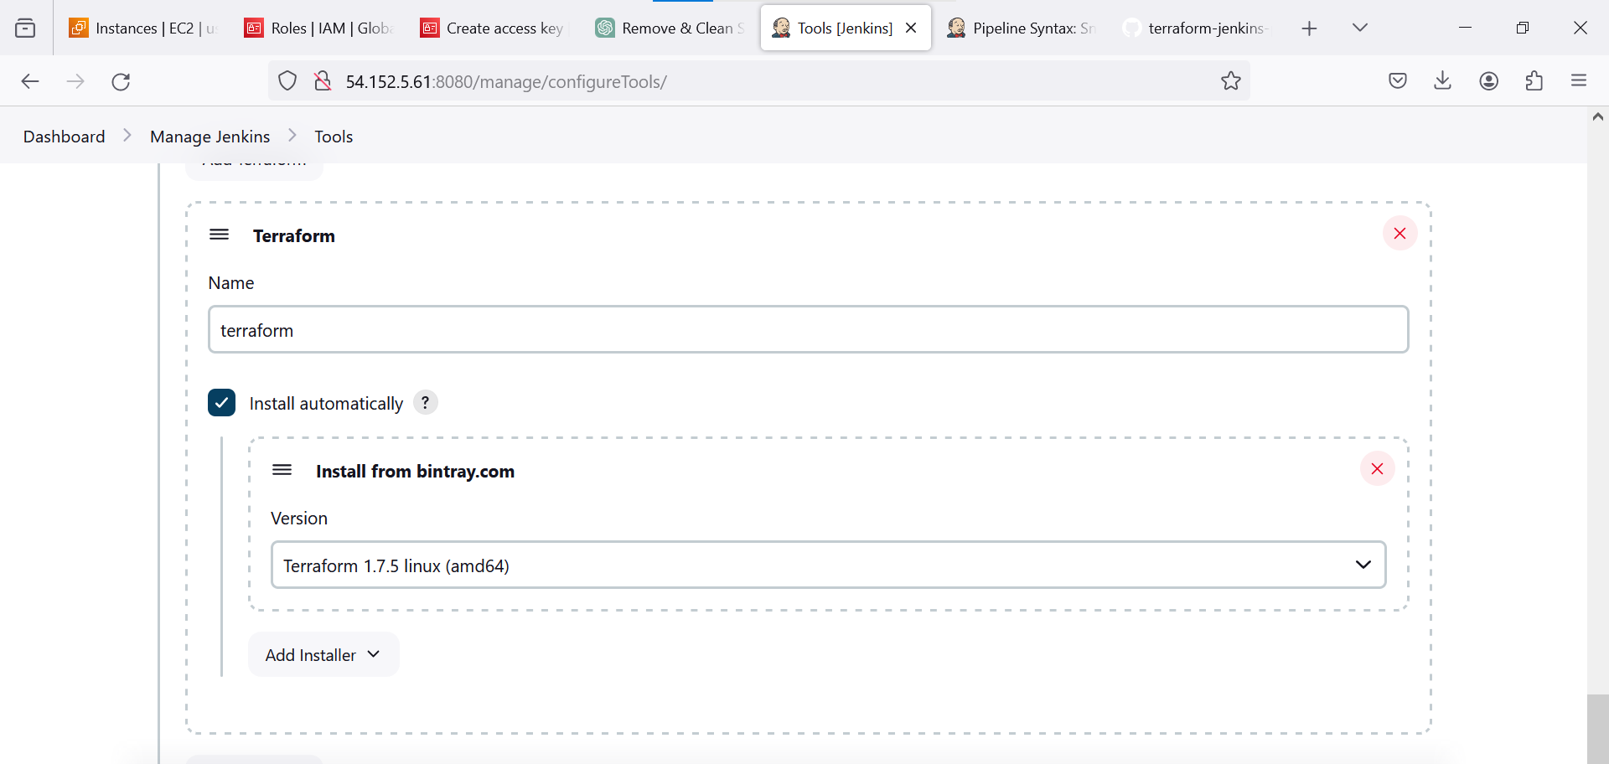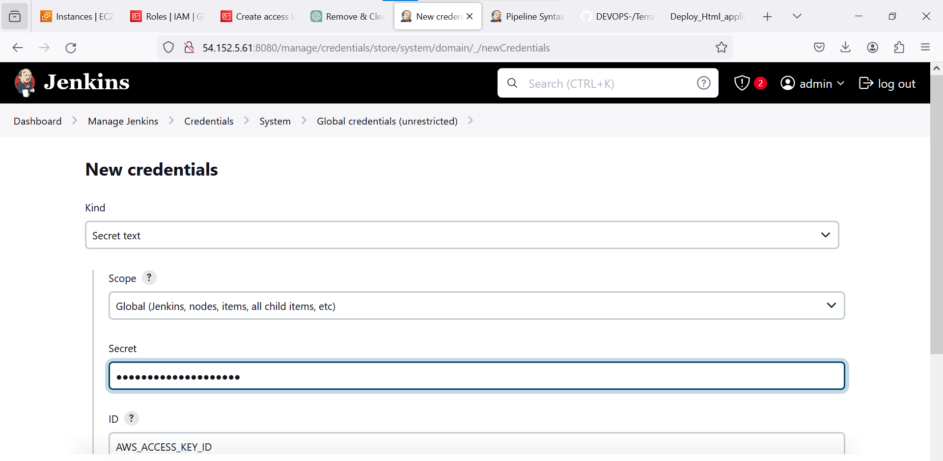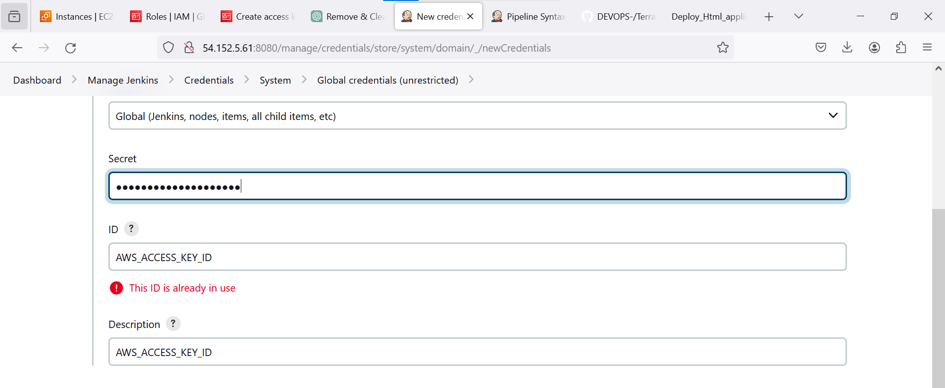 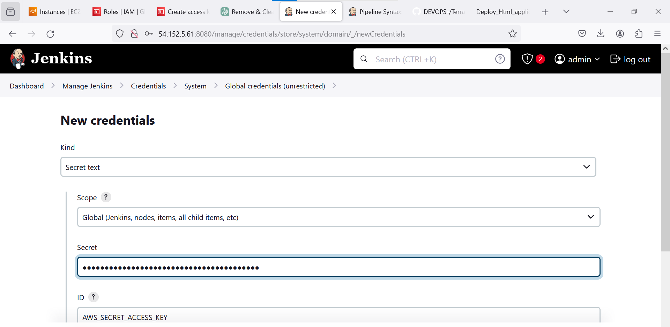 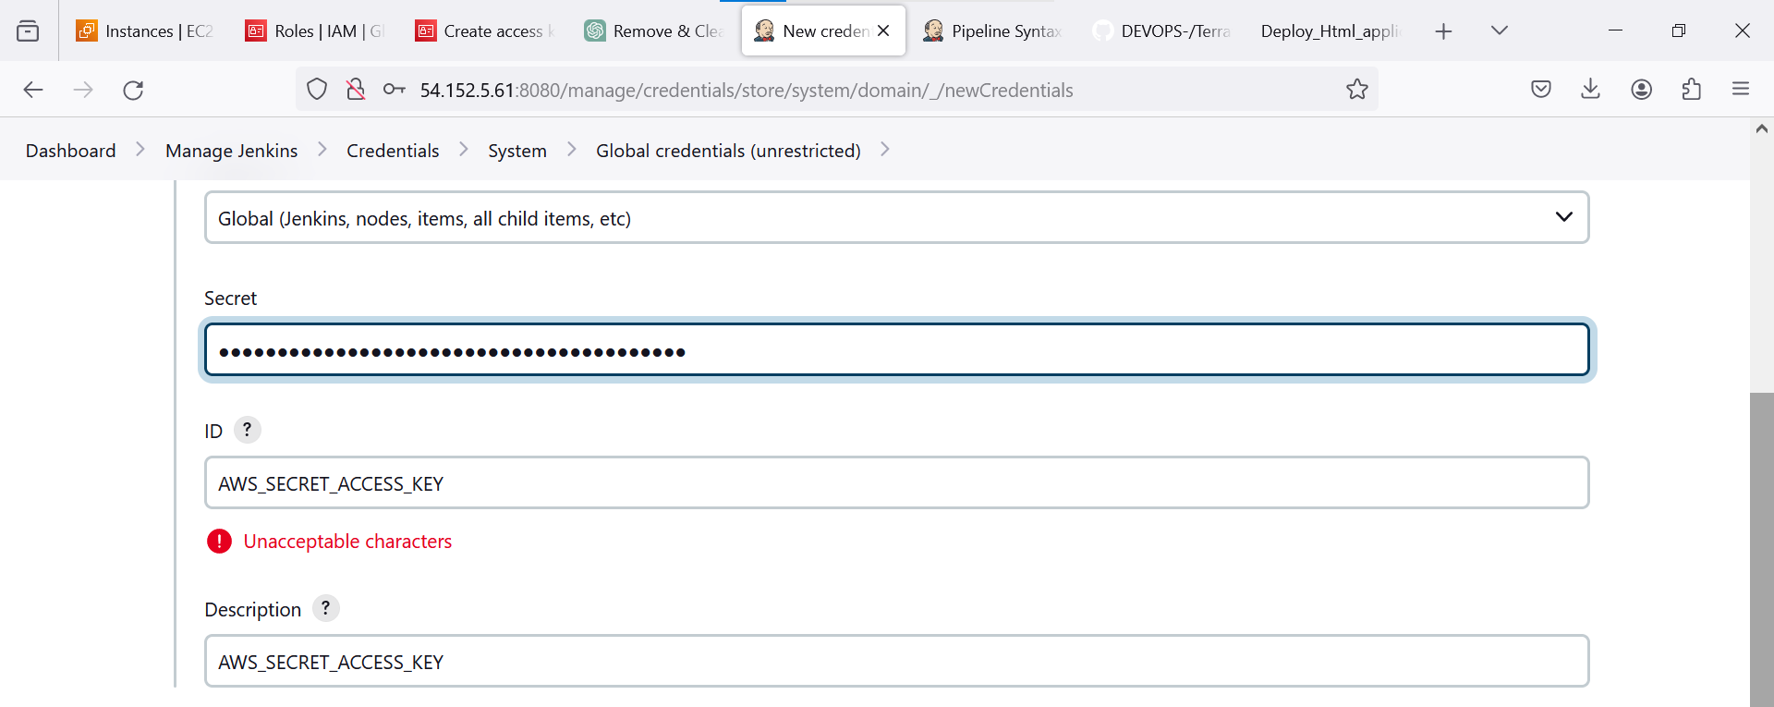 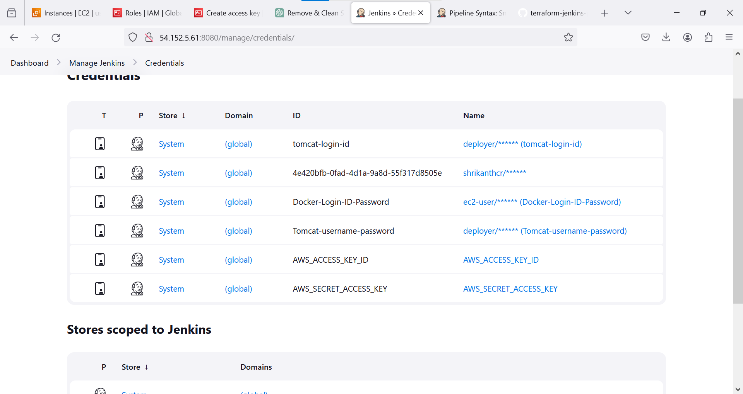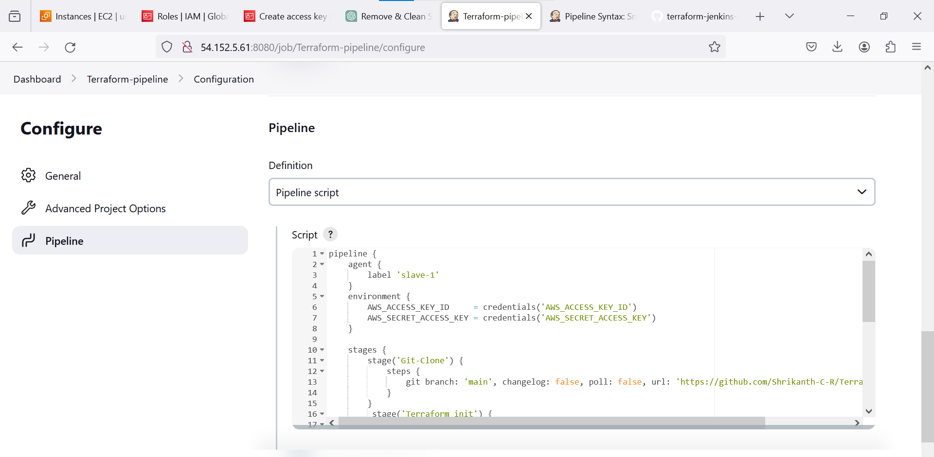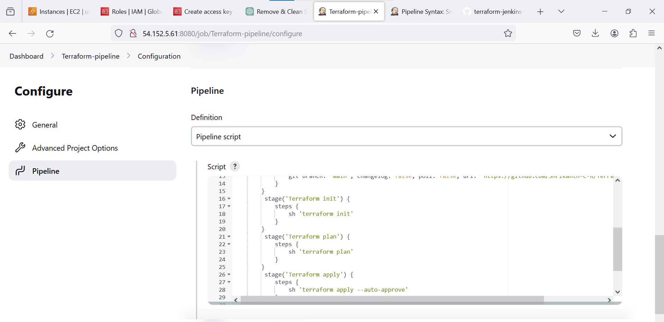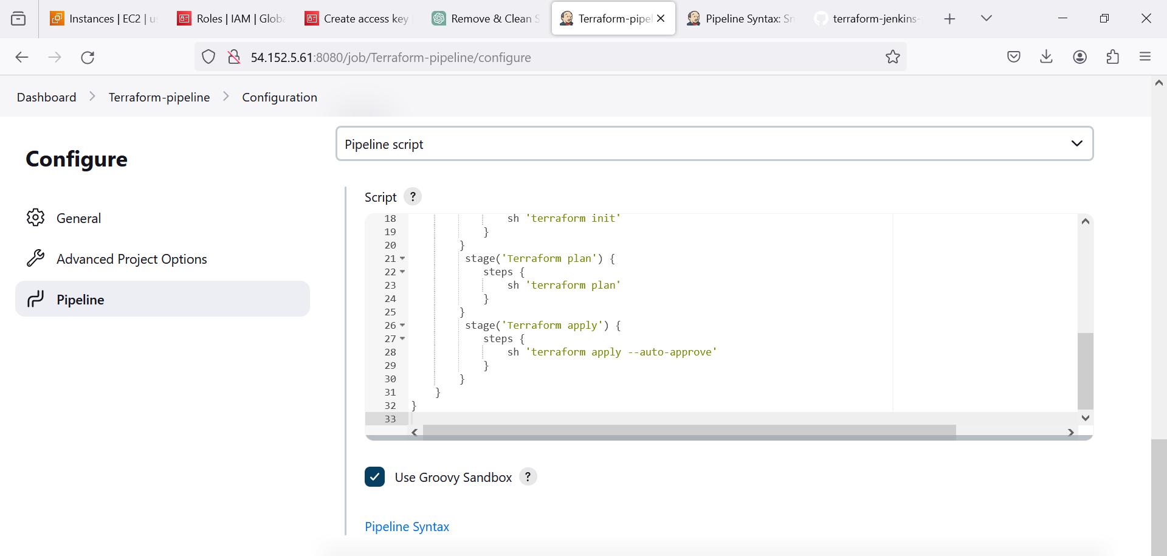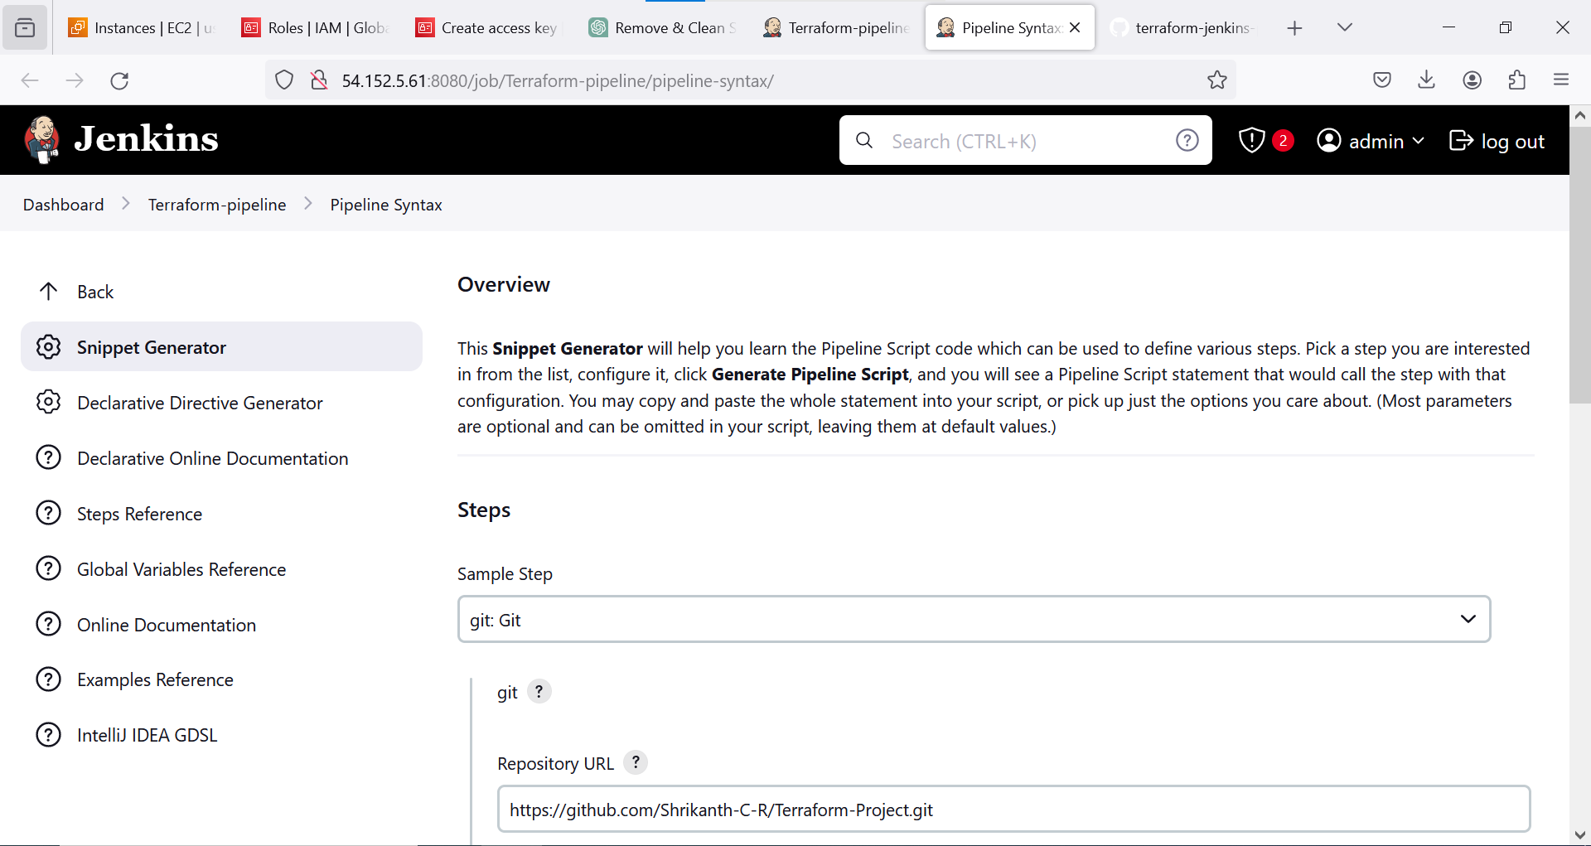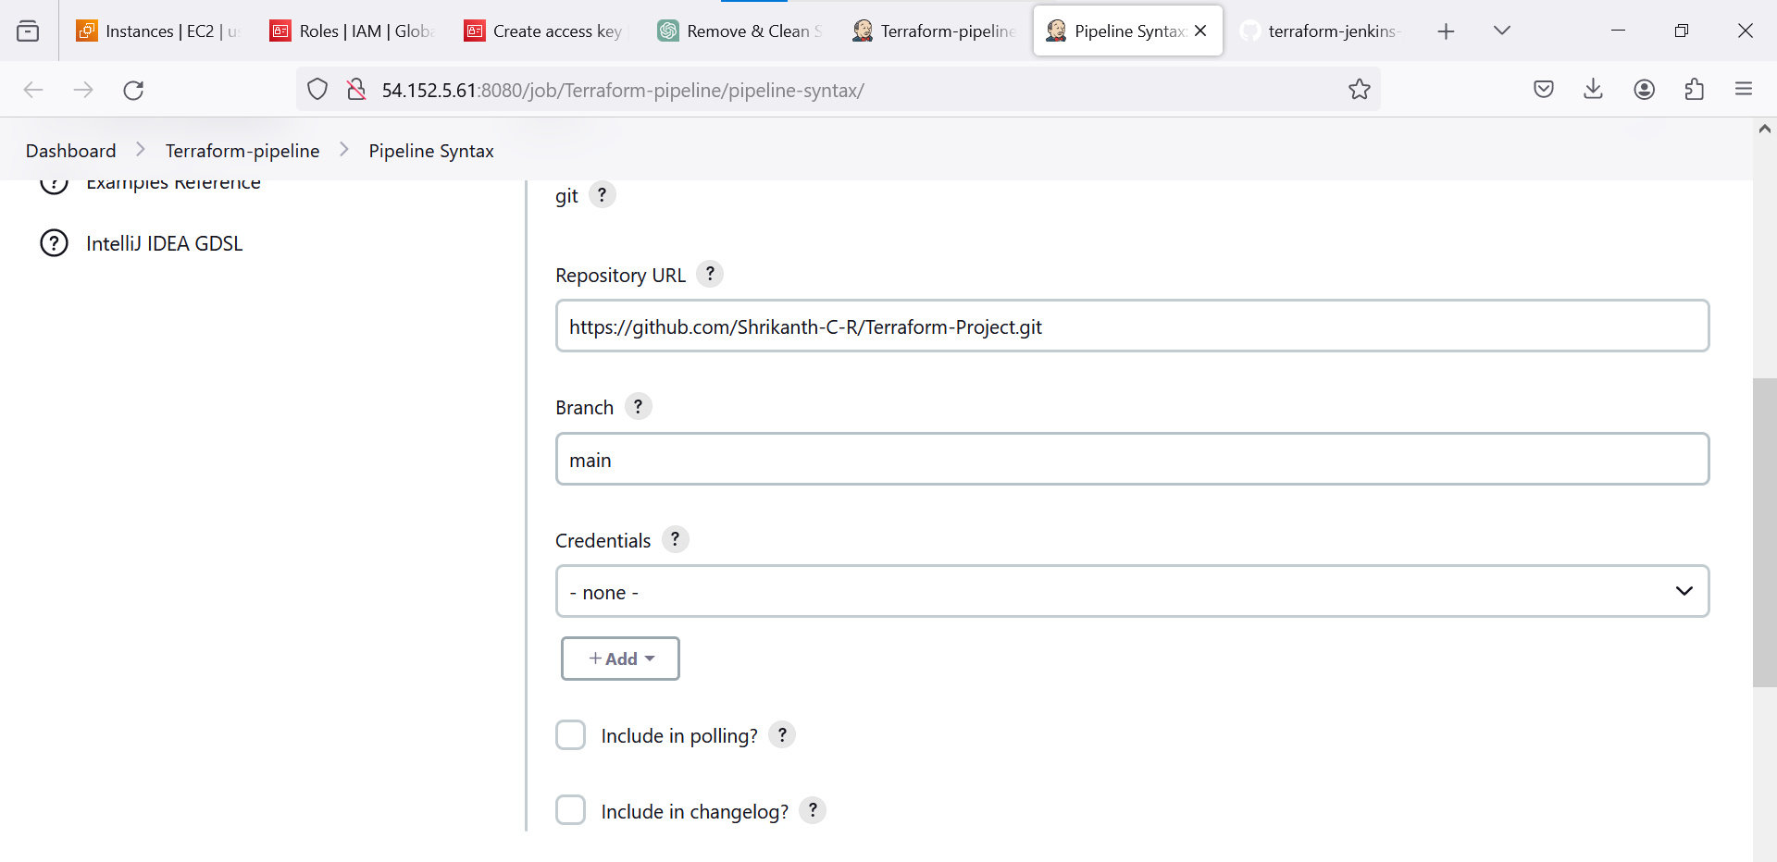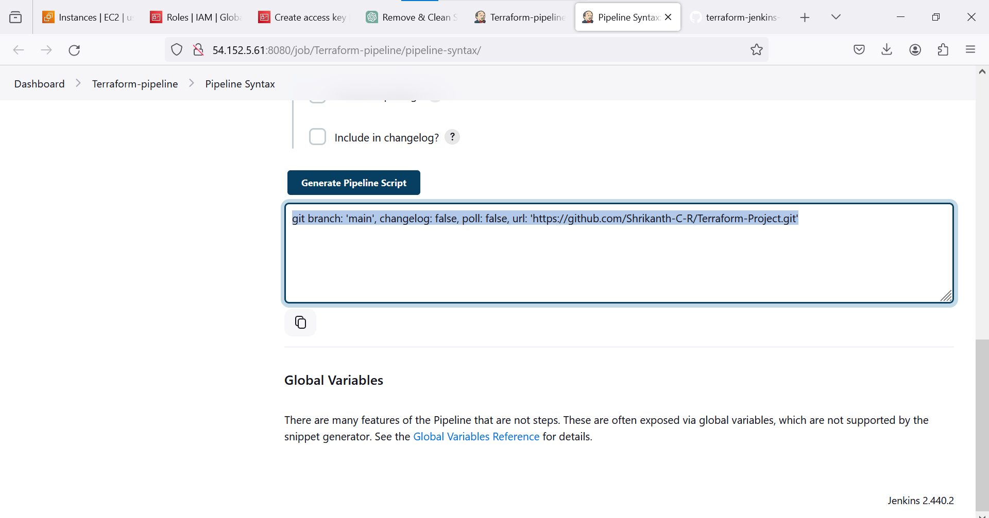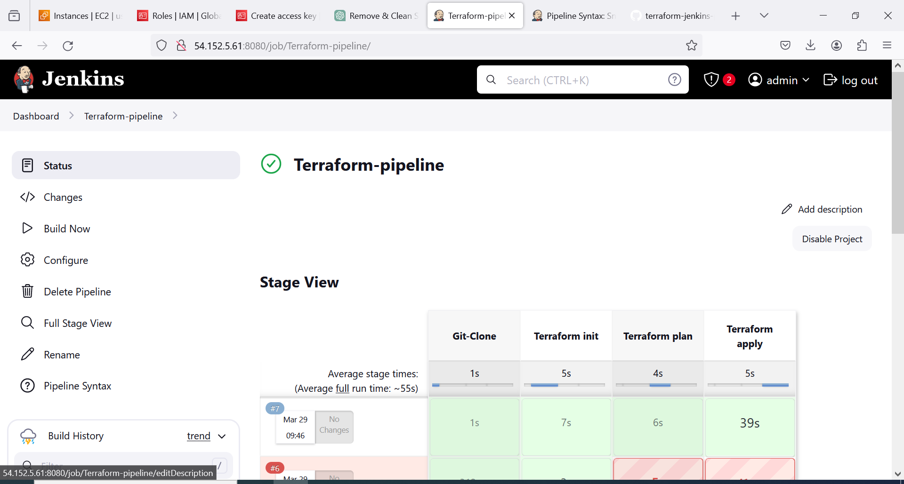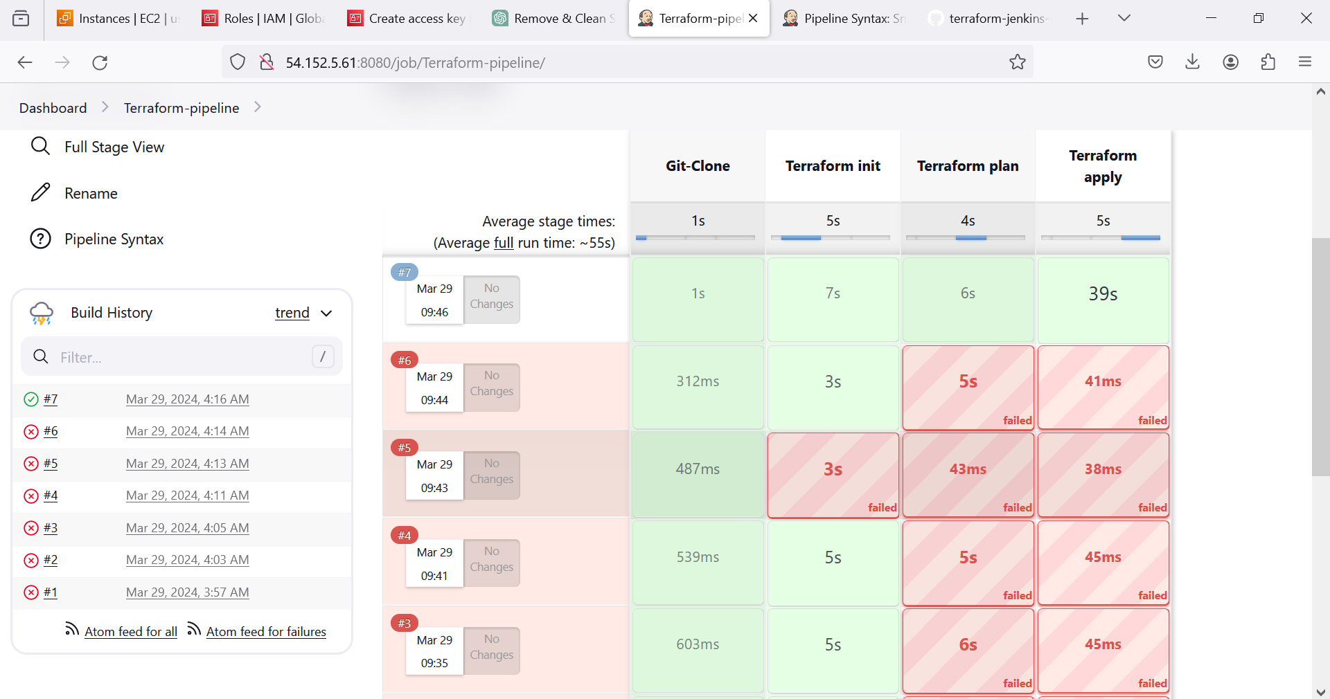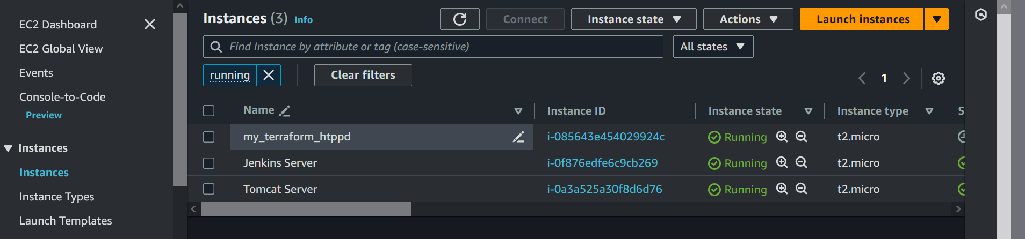

To connect with Master we have to run curl command.

Install Terraform in Slave Machine

We have to choose same terraform version , Which is already installed in slave machine

**Jenkins-Pipeline:**

pipeline {

agent {

label 'slave-1'

}

environment {

AWS_ACCESS_KEY_ID = credentials('AWS_ACCESS_KEY_ID')

AWS_SECRET_ACCESS_KEY = credentials('AWS_SECRET_ACCESS_KEY')

}

stages {

stage('Git-Clone') {

steps {

git branch: 'main', changelog: false, poll: false, url: 'https://github.com/Shrikanth-C-R/Terraform-Project.git'

}

}

stage('Terraform init') {

steps {

sh 'terraform init'

}

}

stage('Terraform plan') {

steps {

sh 'terraform plan'

}

}

stage('Terraform apply') {

steps {

sh 'terraform apply --auto-approve'

}

}

}

}